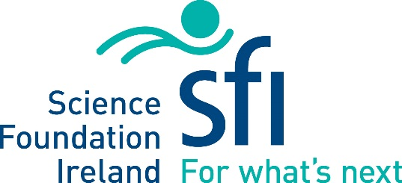

Science Foundation Ireland

St. Patrick’s Day Science Medal
Nomination Form - 2018

Deadline for Submission of Nominations:
20thOctober 2017
Submit (.doc versions only) to sciencemedal@sfi.ie

Medal Nominee’s Details
Title
Name
Institution/Company
Address
Phone
E-Mail
Does the candidate fulfil the eligibility requirements? |  | Yes No
Is the candidate aware of the nomination? |  | Yes No
Please tick the appropriate Medal category – one selection only |  | Academic  Industry

Nominator Details
Name
Institution/Company/Organization
Are you afiliated with an Irish disapora group or business organization/network in the USA? If so which one?
Phone
E-Mail

Documentation Check List
Completed Nomination Form
CV/Resume – max two pages
Support Letter 1 (non compulsory)
Support Letter 2 (non compulsory)

Executive Summary of Contribution/Achievement (2 pages max)
Include examples of the impact of the nominee’s body of work on their field of expertise and how they have demonstrably contributed to the overall advancement of science in either academia or industry in Ireland under each of the headings provided. Please refer to the call document for details on the review process.

Scientific and Technical Excellence

Global Recognition

Engagement with Ireland

